CAPSTONE PROJECT

SHOPNEST STORE SALES DATA ANALYSIS REPORT

**INTRODUCTION**: Shopnest is a premier retail destination renowned for offering a diverse range of high-quality products tailored to meet the needs and desires of modern consumers. Shopnest stands as a beacon of innovation and convenience in the retail landscape.

At Shopnest, they pride themselves on curating an extensive selection of merchandise spanning various categories, including electronics, fashion apparel, home decor, wellness products, and much more. The store is meticulously designed to provide customers with an immersive shopping experience, where they can explore and discover an array of captivating items that resonate with their lifestyle preferences.

**Executive Summary:** This report provides a comprehensive analysis of the sales performance of Shopnest store over a specified period. The analysis includes key metrics such as total revenue, product performance, customer segmentation, and trends observed during the period under review. The insights derived from this analysis will aid in understanding the strengths and weaknesses of the store's sales strategies and help in making informed decisions for future improvements.

**The tasks assigned to do:**

1. **Top Categories by Total Price:** Identify and visually represent the top 10 product categories by total sales.

* The graph below illustrates the top 10 and bottom 10 product categories by total sales:
* The Top 3 Product Categories by Total Sales

1)Health and Beauty: $1.26 million

2)Watches and Gifts: $1.21 million

3)Bed and Bath Table: $1.06 million

* The Bottom 3 Product Categories by Total Sales

1)Security and Services: $283

2)Fashion Children's Clothes: $570

3)CDs, DVDs, and Musicals: $730

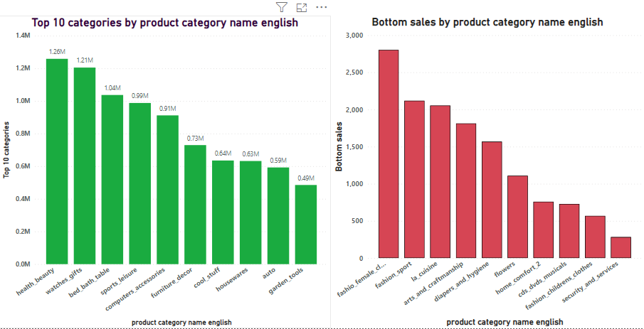

1. **Delayed Orders Analysis:** Determine the number of delayed orders in each category. An order is considered delayed if the actual delivery date is later than the estimated delivery date.

* The number of delayed orders with respect to product category is illustrated in the graph below and the total number of delayed orders is 7826 while the total number of orders is 99.44K .

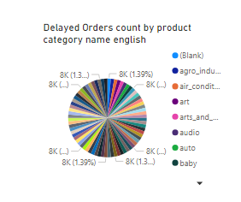

1. **Monthly Comparison of Delayed and On-Time Orders:** Create a dynamic visual that compares the number of delayed orders to the number of orders received earlier for each month. Utilize the drillthrough cross-report feature to provide a detailed analysis of late and on-time deliveries.

* The dynamic visual provided below offers a comparison between the number of delayed orders and the number of orders received earlier for each month.
* From the visualization, it is evident that:

1)The maximum number of delayed orders occurs in the month of April.

2)The highest number of orders received is observed in the month of August.

3)Subsequently, there is a declining trend in the number of orders received after August.

* This analysis provides valuable insights into the order fulfillment process and highlights potential areas for improvement to mitigate delays and manage order volume effectively.

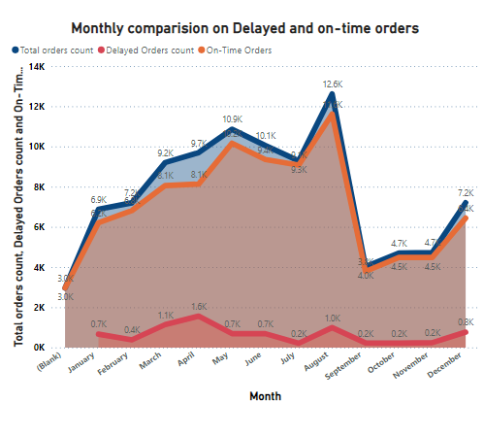

1. **Payment Method Analysis:** Analyze the most frequently used payment methods by customers using a visually appealing representation, such as a pie chart or other suitable visuals.

* The visualization below illustrates the most frequently used payment methods by customers.
* From the visualization, the following observations can be made regarding transaction frequency.
* The most frequently used payment method is credit card, with approximately 12.5 million transactions.
* Following credit card transactions, Boleto is the next commonly used method, accounting for approximately 2.5 million transactions.
* Voucher and debit card transactions follow, with approximately 0.2 million each.

The peak in credit card usage can be attributed to the availability of no-cost EMIs offered by many credit card companies, providing customers with flexible payment options over certain months. This strategy likely contributes to the increased preference for credit card transactions among customers.

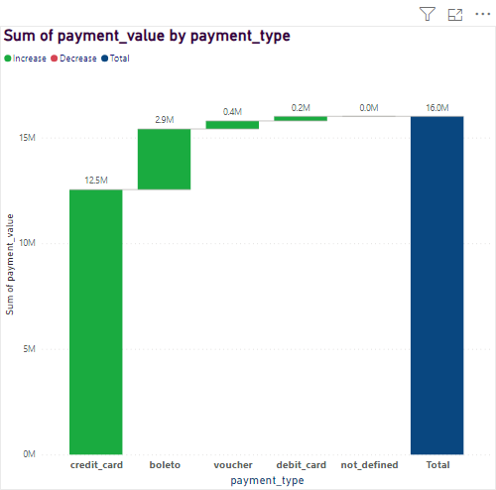

1. **Product Rating Analysis:** Determine the top 10 highest-rated products and the bottom 10 lowest-rated products using a bar or column chart.

* The visualizations below depict the top 10 highest-rated products and the bottom 10 lowest-rated products:
* The top-rated product categories are:

1)Bed and Bath Table: 44,000 reviews

2)Health and Beauty: 40,000 reviews

3)Sports and Leisure: 36,000 reviews

* The bottom-rated product categories are:

1)Security and Services: 5 reviews

2)Fashion Children's Clothes: 36 reviews

3)La Cuisine: 53 reviews

These ratings provide valuable insights into customer satisfaction levels across different product categories, helping businesses identify areas for improvement and better understand consumer preferences.

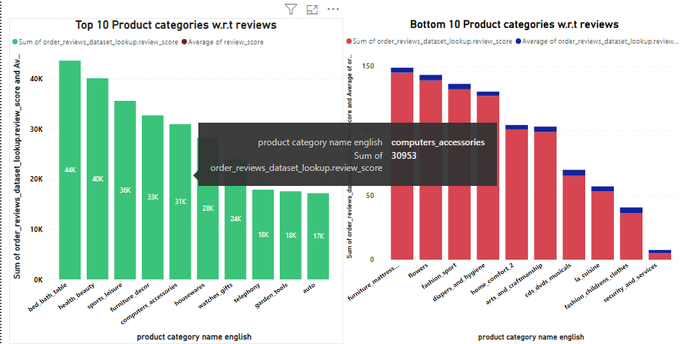

1. **State-wise Sales Analysis:** Identify and visually represent states with high and low sales, providing a clear understanding of regional sales performance.

* The graph below illustrates the sales performance across different states, providing insights into both high and low sales regions:
* From the data, it is evident that:

1)The state with the highest sales is São Paulo (SP), with sales totaling $5.2 million.

2)Conversely, the state with the lowest sales is Roraima (RR), with sales amounting to $7.82 thousand.

This analysis offers a clear understanding of regional sales trends, enabling businesses to identify areas of strength and opportunities for growth in various geographical regions.

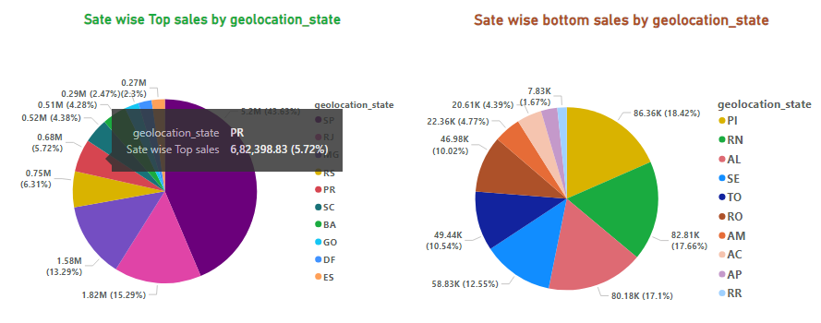

1. **Seasonal Sales Patterns:** Investigate and visualize any seasonal patterns(Quarterly) or trends in sales data over the course of the year.

* The following graphs provide insights into the seasonal patterns and trends in sales data over the course of the year:
* These insights into seasonal patterns and trends in sales data offer valuable information for businesses to optimize their strategies, allocate resources effectively, and capitalize on peak sales periods throughout the year.

**Yearly Sales Trend:**

* From the yearly sales trend analysis.
* There is an overall increasing trend in sales over the years.
* The year 2018 stands out with the maximum sales, reaching $7.4 million.

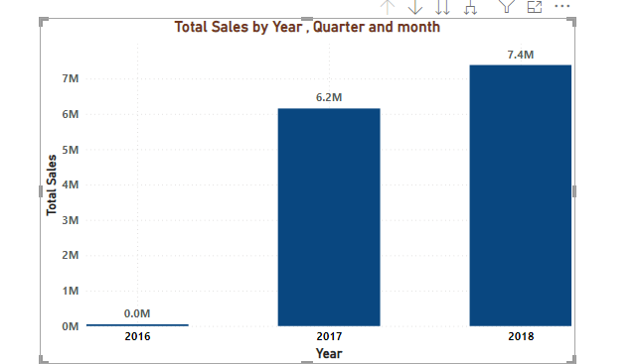

**Quarterly Sales Analysis:**

* In the quarterly analysis The second quarter, spanning from April to June, exhibits the highest sales volume, totaling $4.2 million.

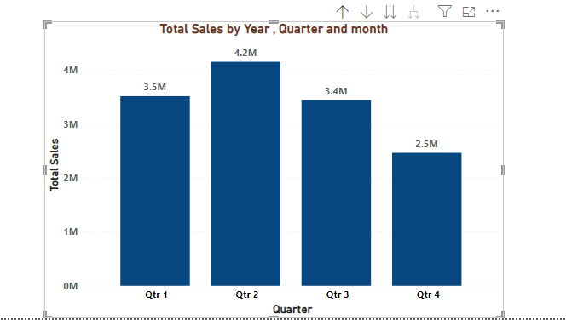

**Monthly Sales Analysis:**

* Analyzing monthly sales May emerges as the month with the highest number of sales, amounting to $1.50 million.

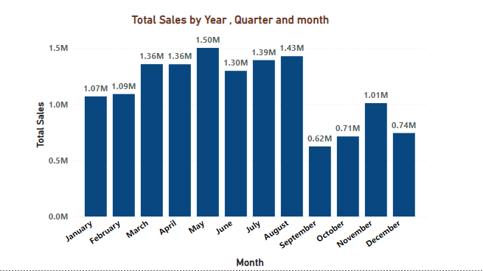

1. **Revenue Analysis:** Determine the total revenue generated by ShopNest Store  and analyze how it changes over time(Yearly). Represent this information through suitable visuals to highlight trends and patterns.

* The graph below illustrates the total revenue generated by ShopNest Store and its changes over the years:
* From the analysis of the revenue trend:

1)The year 2018 stands out with the maximum revenue generation, indicating a high number of sales during that period.

2)There is a noticeable rapid increase in revenue from 2016 to 2017, suggesting significant growth during that period.

3)Subsequently, from 2017 to 2018, while the revenue continues to increase, the rate of growth appears to be more gradual.

This analysis provides valuable insights into the financial performance of ShopNest Store over the years, highlighting periods of rapid growth and identifying trends in revenue generation. Such information is crucial for strategic planning and decision-making within the organization.

